**Topic Name:**

The main aim of this lab session is to provide hands-on experience on

* Getting Help
* Basic Commands
* Navigation
* File System
* simple shell script

1. Getting Help

|  |  |  |  |  |
| --- | --- | --- | --- | --- |
| Task | Command Name | Syntax | Example | Screenshots |
| To get manual page for the known command | man | man “command name” | man ls |  |
| To get manual page for the unknown command | help | help | help |  |
| To know the source file binary |  |  |  |  |
| To know the path of the command | which | which “command name” | which ls |  |
| To know the command is external or internal | type | type “command name” | type cd |  |
| To get help for the internal command | help | Help “command name” | help cd |  |
| To list out bash commands |  |  |  |  |
| To know the usage of the command | --help | “command name” --help | ls --help |  |

1. **Basic Commands**

|  |  |  |  |  |
| --- | --- | --- | --- | --- |
| Task | Command Name | Syntax | Example | Screenshots |
| To know today’s date | Date +%F | Date +%F | Date +%F |  |
| To print calendar | cal -y YYYY | cal -y YYYY | cal -y 2024 |  |
| To print kernel version | uname -r | uname-r | uname-r |  |
| To print default shell | echo $SHELL | echo $SHELL | echo $SHELL |  |
| To print currently logged in user | whoami | whoami | whoami |  |
| To create shortcut for command | alias | alias “alias name=command name” | alias becks=ls |  |
| To delete shortcut | unalias | unalias “alias name” | unalias becks |  |
| To change the timestamp of the file | touch | touch “file name” | touch “CYS45” |  |
| To clear the screen | clear | clear | clear |  |
| To create empty files | Touch | touch “filename” | Touch “CYS45” |  |
| To know disk usage | df | df | df |  |
| To know free space in the system | df | df | df |  |
| To know about the Linux release | lsb_release -a | lsb_release -a | lsb_release -a |  |

1. **Navigation**

|  |  |  |  |
| --- | --- | --- | --- |
| Task | Command | Syntax | Screenshots |
| To navigate home directory | cd | Cd |  |
| To navigate to the parent directory | cd .. | cd .. |  |
| To navigate to the child directory | cd | cd child-directory |  |
| Alternate command to cd |  |  |  |
| To go back to the previous directory | cd - | cd - |  |
| To go to the root directory | cd / | cd / |  |

1. **File System**

|  |  |  |
| --- | --- | --- |
| **Task** | **Syntax** | **Command** |
| **How to identify the file system** |  |  |

1. Create Folder “CYS”

1. Navigate to CYS

1. Create folder LS1 and LS2 under CYS

1. Go back to CYS

1. Working with Files
2. Add commands which you learnt during lab session in the file commands.txt

1. Change the timestamp of the file to yesterday

1. Copy the contents from the file commands.txt to commands_demo.txt

1. Rename the file commands_demo.txt to duplicate

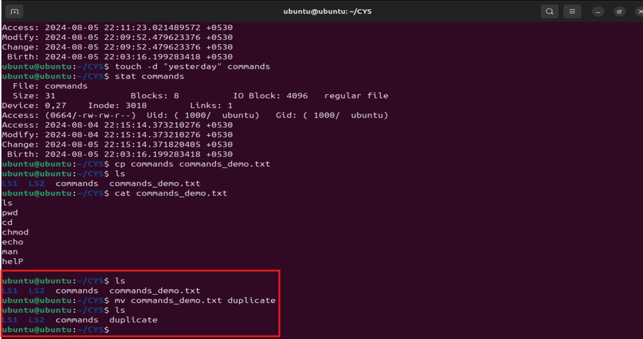

1. Rename all .html to .hldd
2. Delete the file duplicate

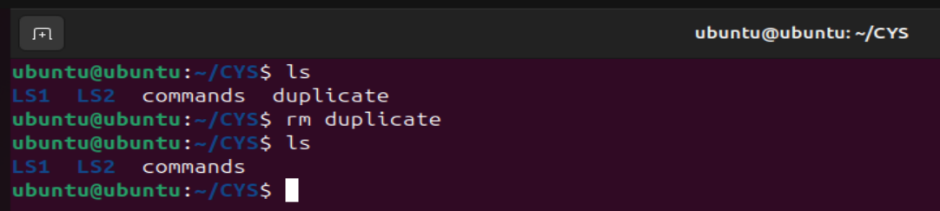

1. Copy the contents commands.txt to unit4 and unit5 (using relative path)
2. Delete the contents from unit5 (using absolute path)
3. Navigate to root

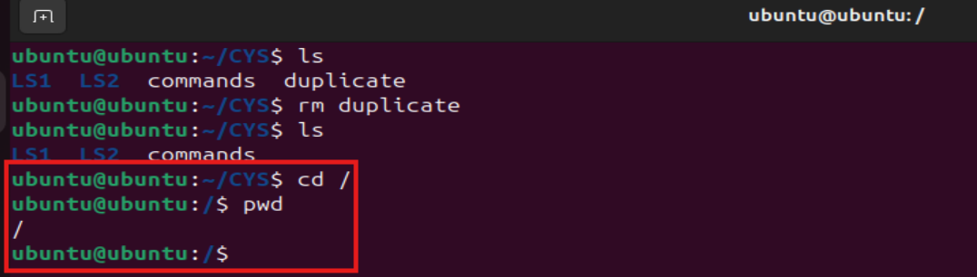

1. List all the files under root



1. Explore all the folders (Do not delete any folder)



1. Navigate to /etc/passwd

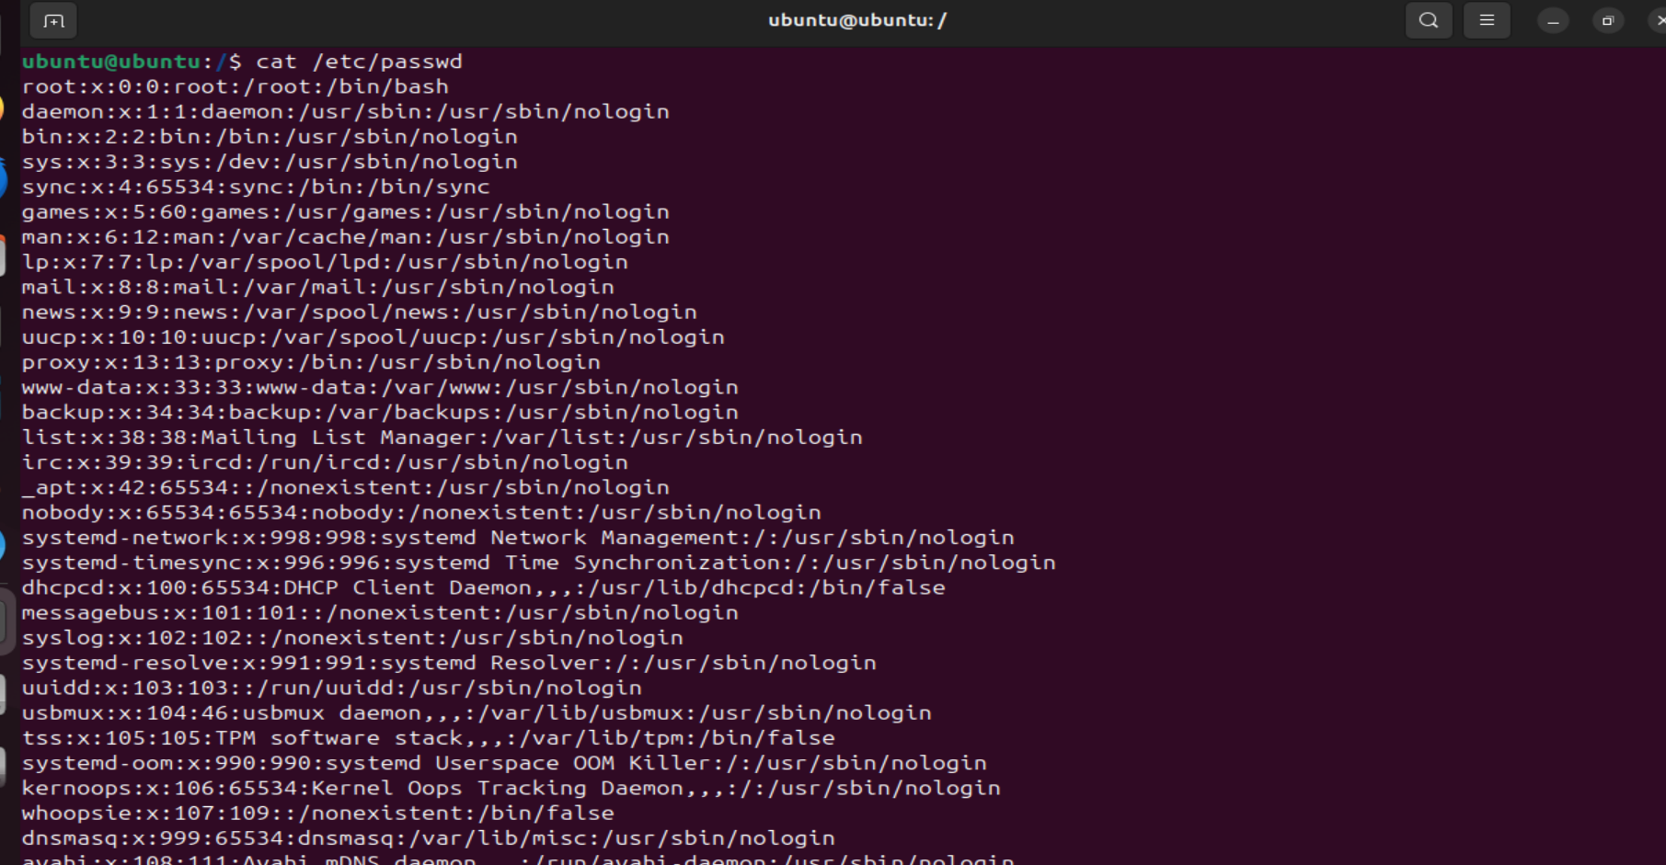

1. Open the file passwd
2. Explore the file passwd
3. Navigate to /etc/group and explore

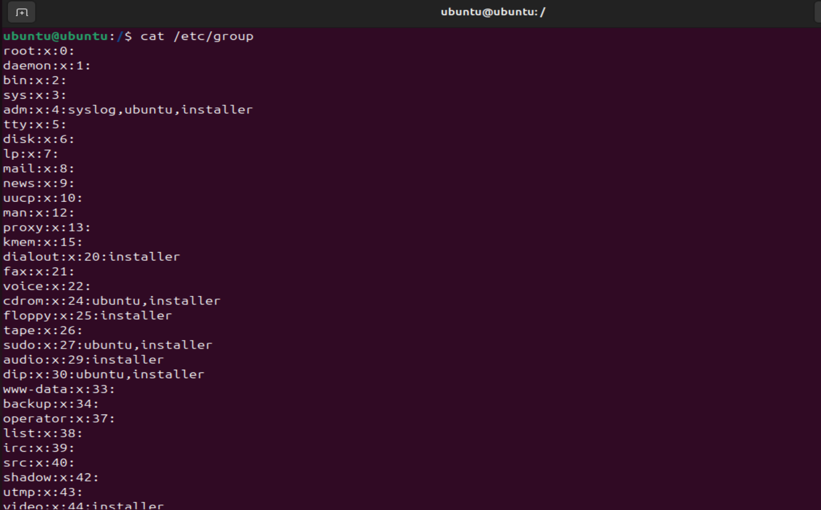

1. **Difference between**

|  |  |
| --- | --- |
| **GUI** | **CLI** |
| This interface to the system makes use of graphical components such windows, menus, and icons. Usually, to navigate, users click buttons, drag objects, and use the mouse. | Is dependent on text commands typed into a command prompt or terminal. Using the keyboard, users input parameters and commands. |
| Because of its background processes and graphical features, GUI programs usually require more memory and CPU power to operate. | Because it uses few resources, it is appropriate for controlling servers and granting remote access. |
| Frequently utilized for desktop programs, multimedia applications, and consumer-focused programs where user-friendliness is crucial. | Suggested for jobs requiring exact control over system resources and configurations, programming, networking, and system management. |

|  |  |
| --- | --- |
| **MAN** | **INFO** |
| This abbreviation stands for "manual." Man pages are usually accessible via a command-line interface (man command) and are arranged into sections such as General commands, System calls, and Library functions. Man sites are often navigated by scrolling across the text or doing keyword searches. | This stands for "information." Nodes in a tree-like hierarchy make up info documents, which enable more structured and interactive navigation. Users can navigate between nodes, click hyperlinks, and obtain more in-depth details on particular subjects. To view these papers from the command line, use the info command. |
| Man pages are often brief and concentrate on offering instant access to information. | info materials are longer and more thorough. |

|  |  |
| --- | --- |
| **Whichis** | **Whereis** |
| The whichis command is less common and may not be available on all Unix-like systems by default. | The whereis command is used to locate the binary, source, and manual page files for a command. |
| whichis makes an effort to give details on the intent or description of the command, like to what you could find in a summary of a manual (man) page. | Whereis normally returns the path of the binary executable, the source code files, and the location of the manual page (if available) when you run it with a command name after it. |

|  |  |
| --- | --- |
| **Terminal** | **Shell** |
| A terminal is a hardware device or software program that allows users to interact with the computer system through a command-line interface (CLI). | A shell is a command-line interpreter that provides an interface for users to interact with the operating system. |
| a terminal provides a text-based interface where users can enter commands and view their output. It acts as a gateway to access the shell. | The shell interprets the commands entered by the user via the terminal and communicates with the operating system to execute those commands |

1. Write a simple shell script to print your name and your hobbies!

